**Question – 1 Write a C++ program to demonstrate the use of try, catch block with the argument as an integer and string using multiple catch blocks..**

**Ans.**

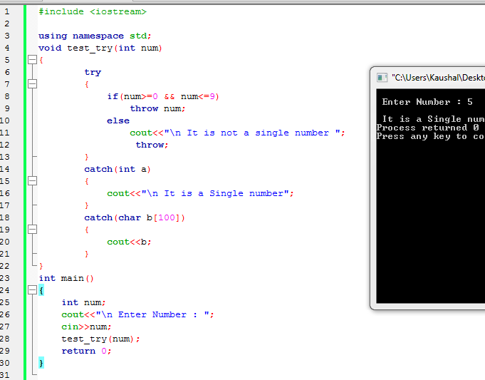

**Question – 2 Write a C++ program to demonstrate try, throw and catch statements.**

**Ans.**

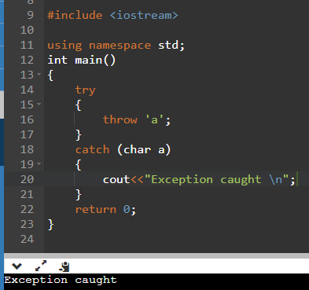

**Question – 3 Write a C++ program to perform arithmetic operations on two numbers and throw an exception if the dividend is zero or does not contain an operator.**

**Ans.**

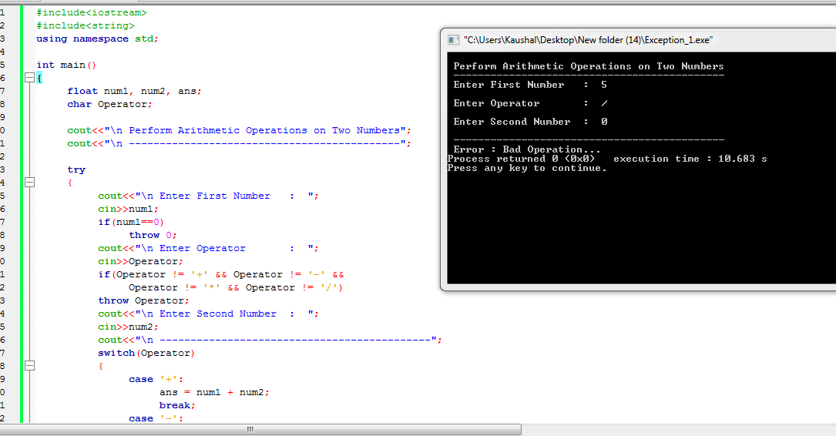

**Question – 4 Write a C++ program to accept an email address and throw an exception if it does not contain @ symbol.**

**Ans.**

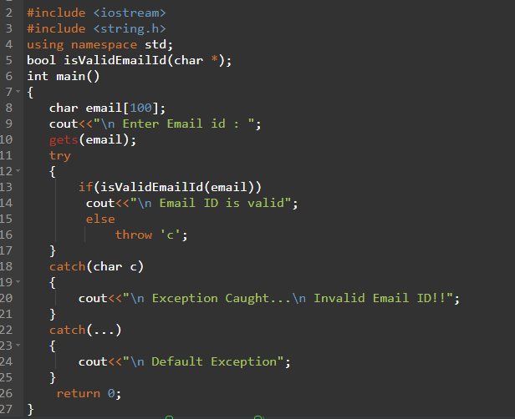

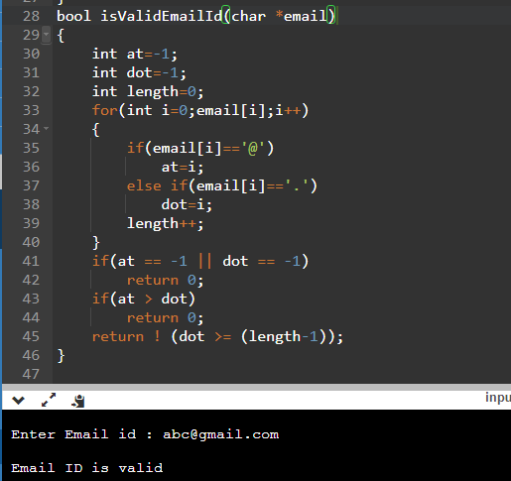

**Question – 5 Write a C++ program to accept a mobile number and throw an exception if it does not contain 10 digits.**

**Ans.**

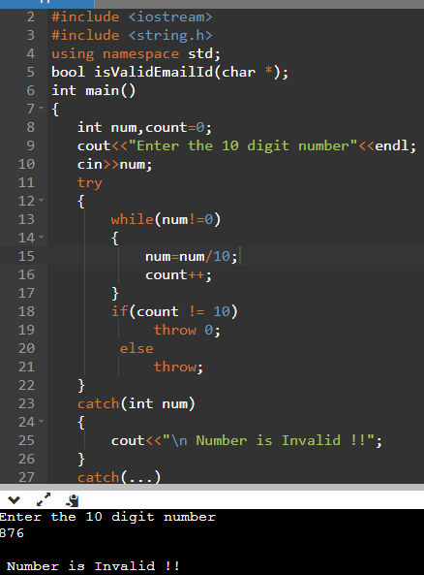

**Question – 6 Write a C++ program to accept area pin code and throw an exception if it does not contain 6 digits..**

**Ans.**

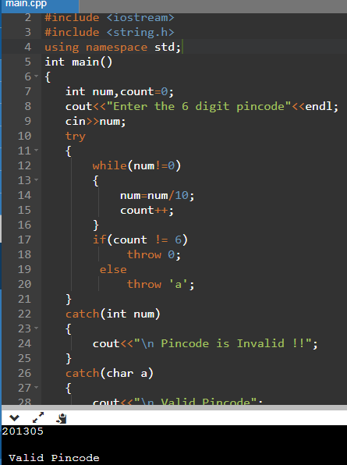

**Question – 7 Write a C++ program to accept a username if the username has less than 6 characters or does contain any digit or special symbol.**

**Ans.**

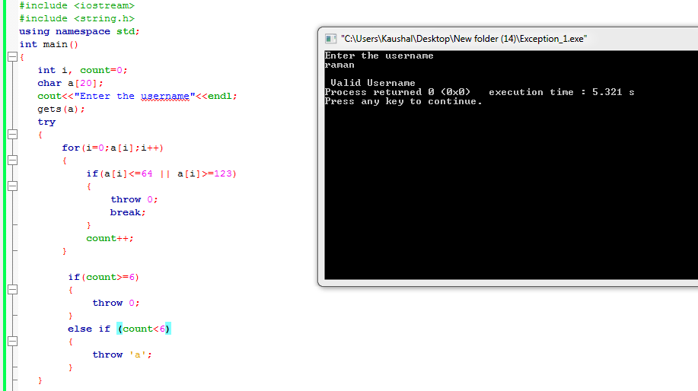

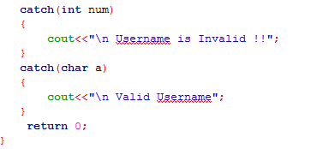

**Question – 8 Write a C++ program to accept a password and throw an exception if the password has less than 6 characters or does not contain a digit or does not contain any special character or does not contain any capital letter..**

**Ans.**

